Field Report on Waste Containers and Sensor-Based Monitoring Systems in Rio Maior, Portugal
Findings from On-Site Inspection, 1 October 2025

Contents
1. Ultrasonic Fill-Level Sensors in the 360Waste Smart Waste Management System 1
2. Types of Recycling Containers in Rio Maior 2
2.1. Blue Containers – Paper and Cardboard 2
2.2. Green Containers – Glass 2
2.3. Yellow Containers – Mixed Packaging (Plastics and Metals) 2
3. Analysis of Selected Containers and Fill-Level Sensors 3

Ultrasonic Fill-Level Sensors in the 360Waste Smart Waste Management System
Within the framework of the 360Waste solution developed in Portugal by EVOX Technologies, ultrasonic fill-level sensors are installed inside the lids of selected waste containers. These sensors emit ultrasonic waves towards the waste surface, measure the return time, and calculate the percentage of fill. The information is then transmitted to the 360Waste central monitoring platform, supporting route optimization, scheduling, and prevention of overflow.
The broader 360Waste system combines both hardware and software modules, including a management platform, route optimization tools, access control mechanisms, vehicle integration, and fill-level sensors. Through the GoBin mobile application, citizens can locate nearby containers, request collection, and report anomalies. Access control features using NFC cards or identifiers also allow municipalities to monitor waste disposal per user, facilitating policies such as “the polluter pays.” Volume sensors further ensure that containers are only collected when reaching critical thresholds, increasing operational efficiency and reducing costs.
During the field inspection in Rio Maior, it was observed that not all containers were equipped with 360Waste sensors, suggesting that deployment remains limited to specific sites, likely as part of a pilot phase or in high-demand areas.
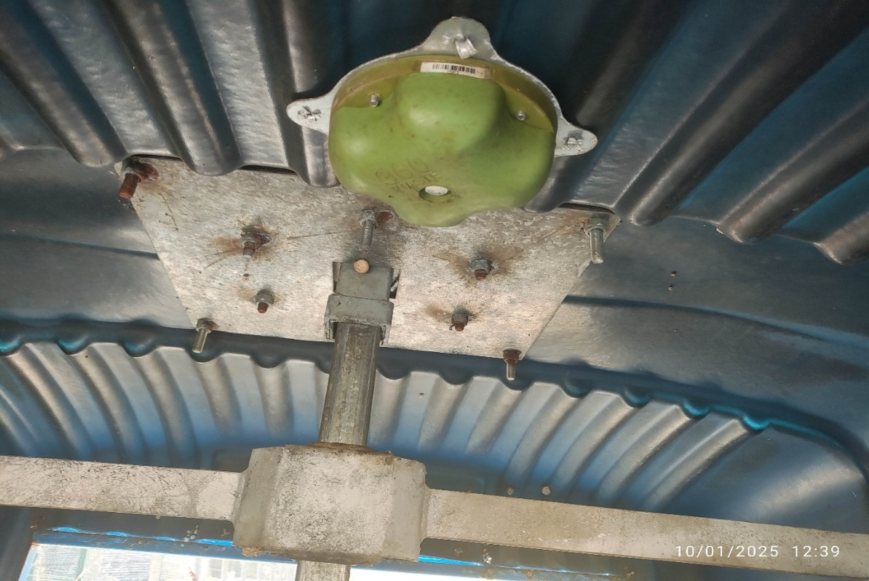

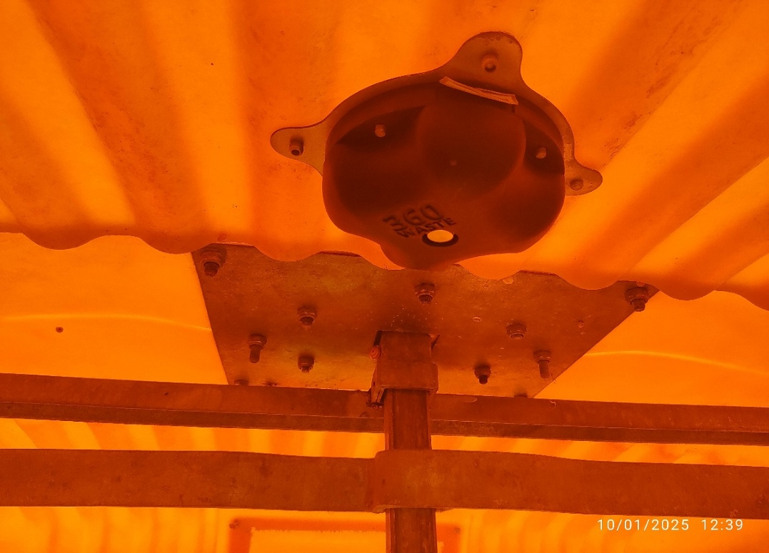

Types of Recycling Containers in Rio Maior
The recycling system in Rio Maior relies on a standardized set of color-coded containers that separate waste streams at the source. These containers are strategically placed across the municipality and, in some cases, equipped with smart sensors to monitor fill levels. The main categories are as follows:

Blue Containers – Paper and Cardboard
Blue containers are designated for the disposal of paper-based packaging and products, including newspapers, magazines, cardboard boxes, office paper, and other printed materials. Their purpose is to divert recyclable fibers from landfills and support the paper recycling industry. In certain locations, sensors provide real-time data on fill levels, enabling optimized collection schedules.

Green Containers – Glass
Green containers are used for glass packaging waste, such as bottles, jars, and other glass containers. Glass is one of the most sustainable materials, as it can be recycled indefinitely without loss of quality. The placement of these containers is intended to ensure accessibility for households and to maximize recycling participation.

Yellow Containers – Mixed Packaging (Plastics and Metals)
Yellow containers are designated for lightweight packaging, particularly plastics and metals. This category includes plastic bottles, plastic bags, aluminium cans, and tin containers. Because this waste stream tends to fill more quickly, especially in urban areas, selected containers are fitted with ultrasonic fill-level sensors. These devices transmit real-time information to the central system, helping to prevent overflow and to optimize collection routes.
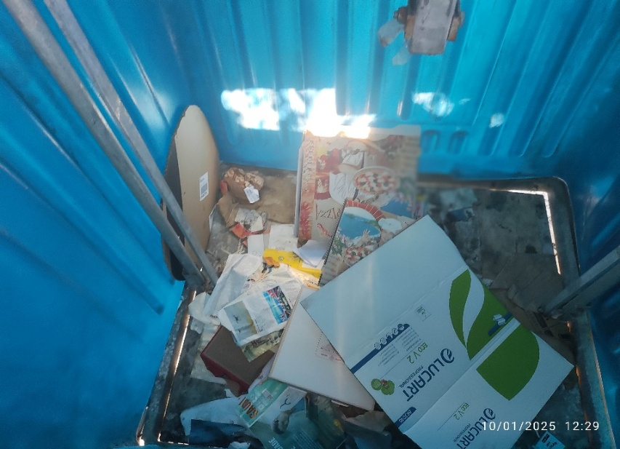
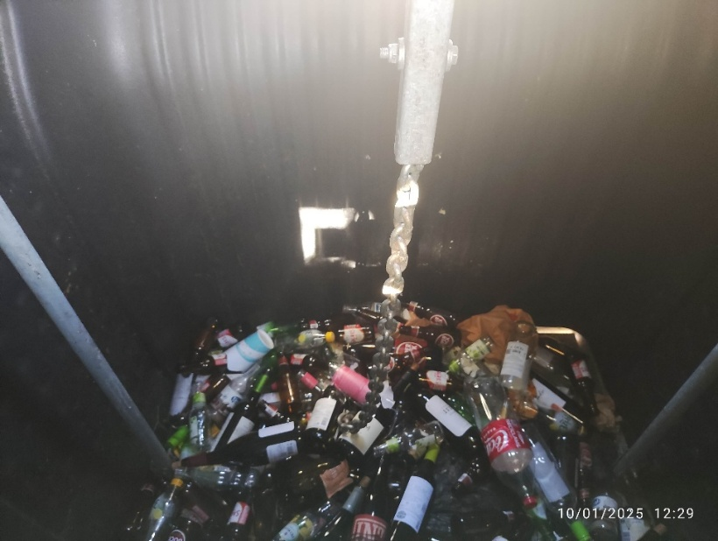
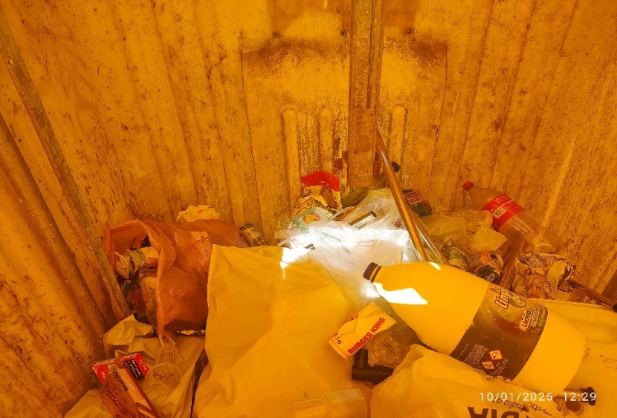
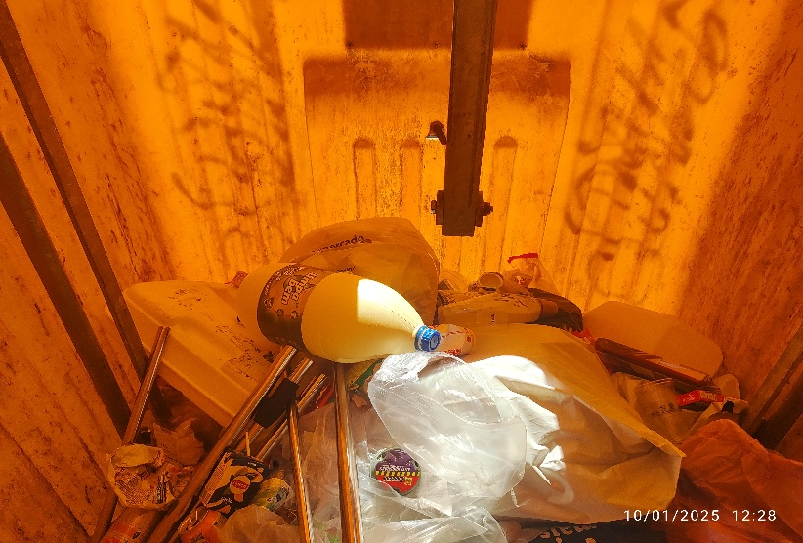

Analysis of Selected Containers and Fill-Level Sensors
In the city of Rio Maior, waste containers are typically placed in clusters of three units: a blue container for paper and cardboard, a green container for glass, and a yellow container for mixed packaging (plastics and light metals). Each container is dedicated to a specific waste stream, meaning that no single container accepts multiple waste types simultaneously; each unit collects only one category of waste. This configuration ensures proper source separation.
Although these containers are very similar in size, shape, and design—and are often difficult to distinguish without considering their colour—only some of them are equipped with ultrasonic fill-level sensors. In most observed locations, only one container within each cluster was fitted with a sensor, while the others lacked monitoring equipment. This selective installation suggests that the fill-level monitoring technology has been implemented as part of a pilot or phased approach, focusing primarily on high-demand waste streams rather than achieving full coverage across all container types.
In addition to sensor data, driver observations were also included in this analysis, as drivers inspect and manually record the fill levels of a much larger number of containers during their collection rounds. These field observations provide valuable complementary information, particularly for containers without sensors, and contribute to a better understanding of filling behaviour and collection frequency across the city.
However, it should be noted that driver-recorded data may be subject to human error. Factors such as visual estimation differences, poor lighting conditions, fatigue, or the fast pace of collection operations can reduce accuracy. Therefore, driver observations should be used alongside quality control procedures and cross-validation with sensor data to ensure the reliability of the results.
This selective installation strategy can be attributed to financial and resource limitations, as equipping all containers with sensors would incur significant costs. Consequently, the municipality or project operator has adopted a phased approach, installing sensors on only a portion of the containers and prioritizing those associated with higher waste generation and demand.
While this method enables targeted monitoring and partial optimization of collection routes, the lack of full coverage across all waste types results in data gaps and may reduce the long-term effectiveness of smart waste management. It should also be noted that some of the sensor data included negative values, which likely indicate calibration errors or technical issues in data transmission rather than actual container conditions. These anomalies emphasize the need for more precise calibration and regular maintenance protocols, which may require additional financial resources to ensure data accuracy and reliability over time.
Ultimately, combining sensor data with driver observations can create a more effective and resilient waste management framework. Sensor data provide automated, real-time information on container fill levels, while driver observations cover a broader set of locations lacking monitoring equipment. Integrating these two data sources allows municipal managers to perform comprehensive analyses, identify filling patterns more accurately, optimize collection scheduling, and prevent inefficient resource allocation. In medium-sized cities such as Rio Maior, this integrated approach can serve as a practical and transitional solution toward the implementation of fully smart waste management systems.
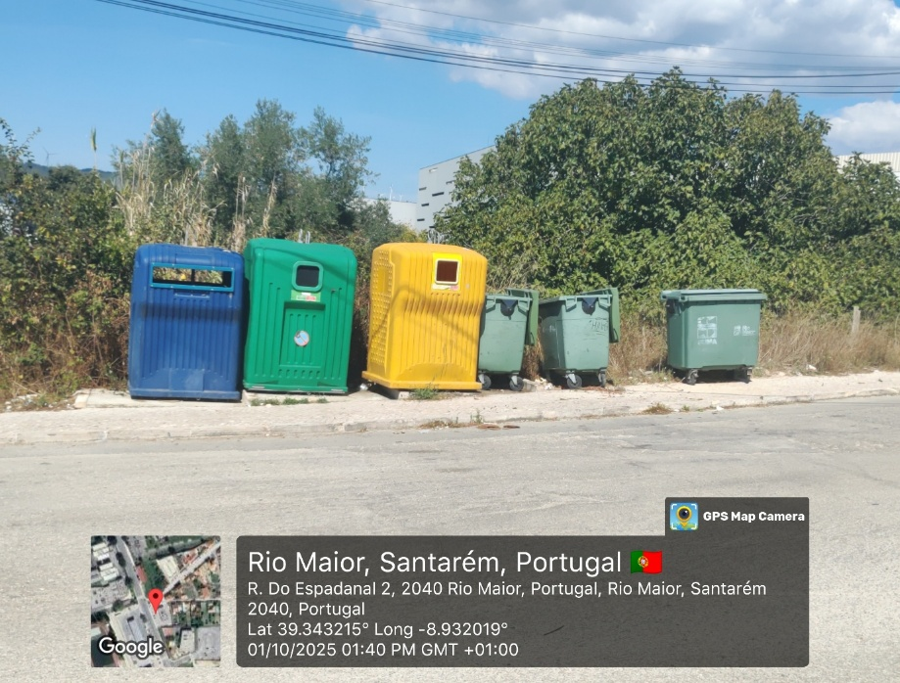
TITAN container identification could not be confirmed using the available data.

On-site Observation (Photo) | Data Recorded in Excel | Avg. Fill Level (2023) | Max. Fill Level (2023) | coordinates of photo
Blue container → Paper & Cardboard | no record for this location | – | – | Longitude: -8.932019°
Green container → Glass | no record for this location | – | – | Latitude: 39.343215°
Yellow container → Mixed Packaging (plastics & metals) | ID = 470, Type = TITAN, Volume = 2500 L, Waste = Mistura de embalagens |  |  | –
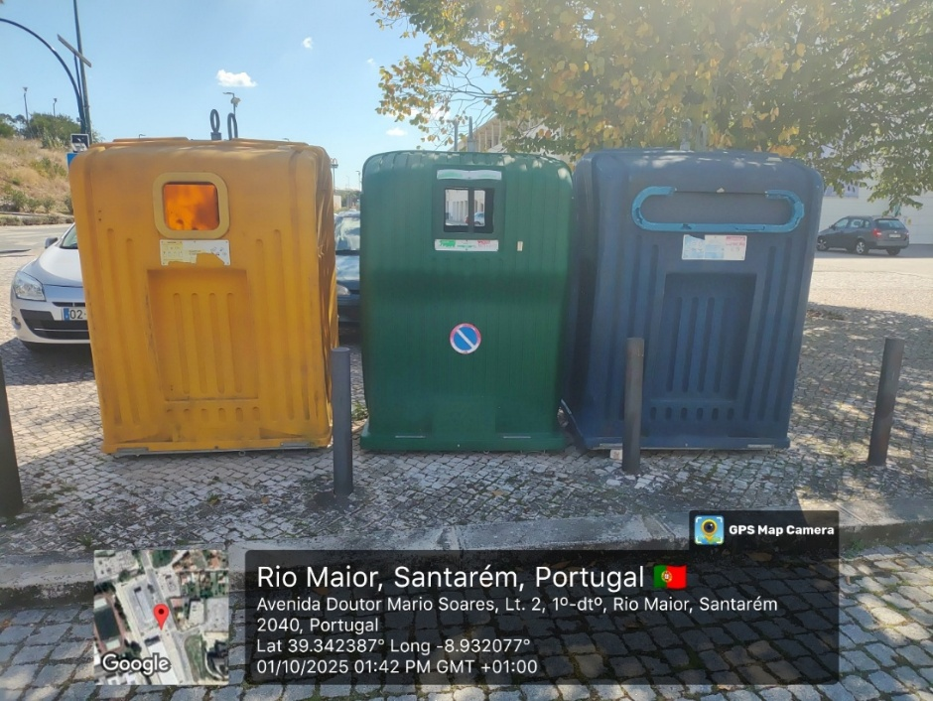

On-site Observation (Photo) | Data Recorded in Excel | Avg. Fill Level (2023) | Max. Fill Level (2023) | coordinates of the photo
Blue container → Paper & Cardboard | ID (idcontento): 7945  Type: VRL, Volume: 2500 L |  |  | Longitude: -8.932077°
Green container → Glass | no record for this location | – | – | Latitude: 39.342387°
Yellow container → Mixed Packaging (plastics & metals) | no record for this location | – | – | –

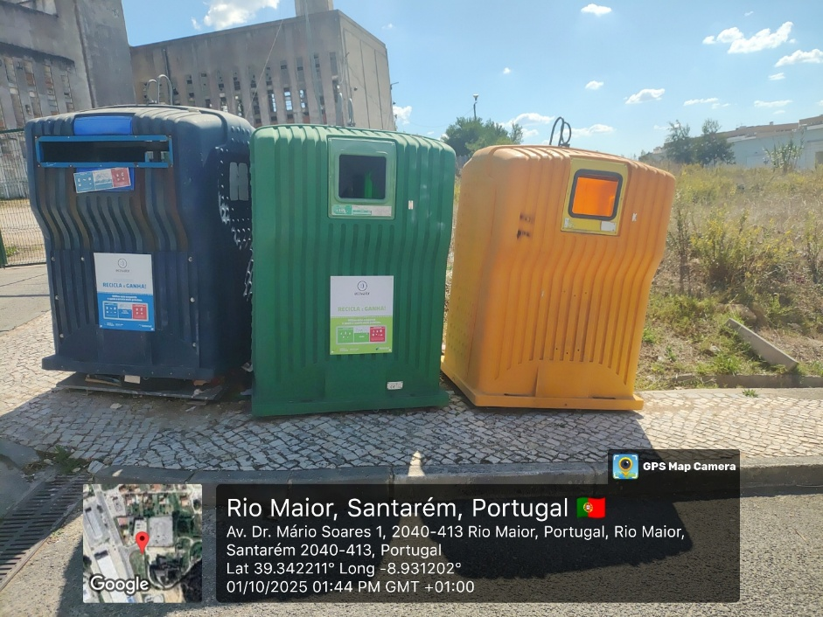
OVO container identification could not be confirmed using the available data, as the record refers to three waste types (paper, glass, and plastic), while the containers shown in the photo are each designed to hold only one specific waste type.

On-site Observation (Photo) | Data Recorded in Excel | Avg. Fill Level (2023) | Max. Fill Level (2023) | coordinates of the photo
Blue container → Paper & Cardboard | no record for this location | – | – | Longitude: -8.931202°
Green container → Glass | no record for this location | – | – | Latitude: 39.342211°
Yellow container → Mixed Packaging (plastics & metals) | ID (idcontento): 1527  Type:OVO, Volume: 2500 L  Waste: Mistura de embalagens | paper, glass, plastic |  | –

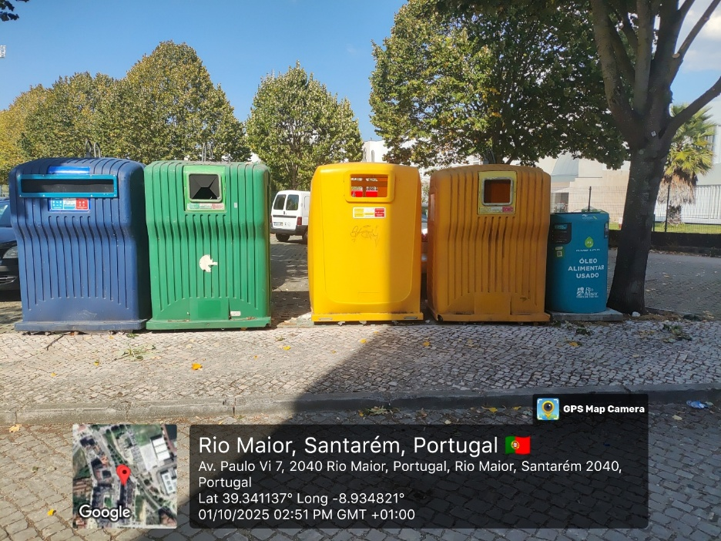
OVO container identification could not be confirmed using the available data, as the record refers to three waste types (paper, glass, and plastic), while the containers shown in the photo are each designed to hold only one specific waste type.

On-site Observation (Photo) | Data Recorded in Excel | Avg. Fill Level (2023) | Max. Fill Level (2023) | coordinates of the photo
Blue container → Paper & Cardboard | no record for this location | – |  | Longitude: -8.934821°
Green container → Glass | no record for this location | – | – | Latitude: 39.341137°
Yellow container → Mixed Packaging (plastics & metals) | ID (idcontento): 18704  Type: OVO,Volume: 2500 L | paper, glass, plastic | – | –
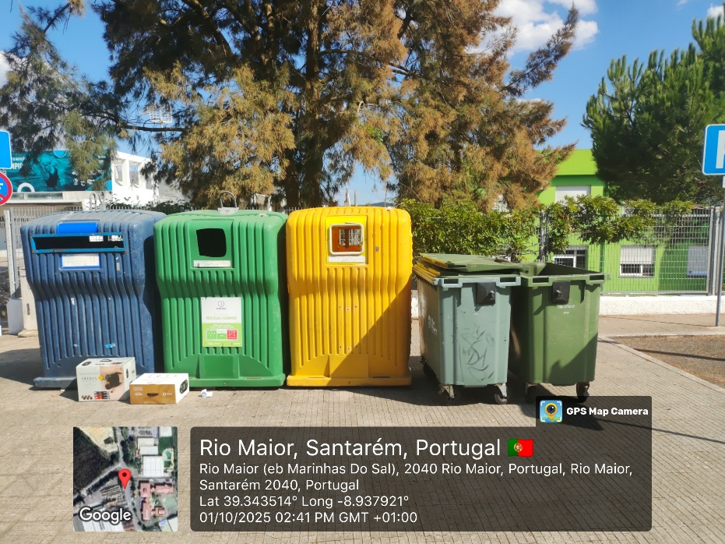
OVO container identification could not be confirmed using the available data, as the record refers to three waste types (paper, glass, and plastic), while the containers shown in the photo are each designed to hold only one specific waste type.

On-site Observation (Photo) | Data Recorded in Excel | Avg. Fill Level (2023) | Max. Fill Level (2023) | coordinates of the photo
Blue container → Paper & Cardboard | no record for this location | – |  | Longitude: -8.937921°
Green container → Glass | no record for this location | – | – | Latitude: 39.343514°
Yellow container → Mixed Packaging (plastics & metals) | ID (idcontento): 18704  Type: OVO,Volume: 2500 L | paper, glass, plastic | – | –

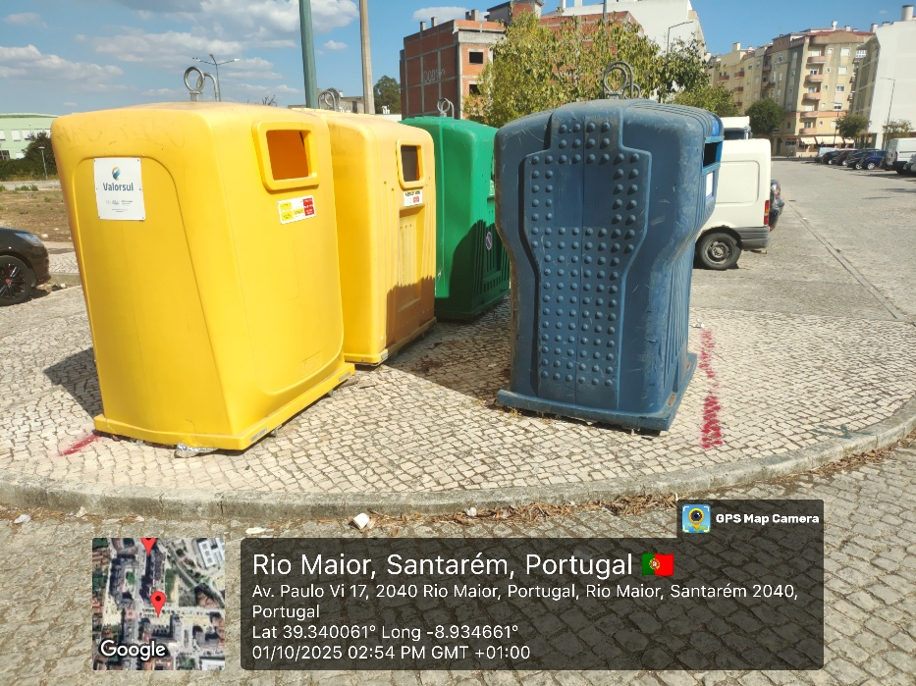

OVO container identification could not be confirmed using the available data, as the record refers to three waste types (paper, glass, and plastic), while the containers shown in the photo are each designed to hold only one specific waste type.

On-site Observation (Photo) | Data Recorded in Excel | Avg. Fill Level (2023) | Max. Fill Level (2023) | coordinates of the photo
Blue container → Paper & Cardboard | no record for this location | – |  | Longitude: -8.934661°
Green container → Glass | no record for this location | – | – | Latitude: 39.340061°
Yellow container → Mixed Packaging (plastics & metals) | ID (idcontento): 18704  Type: OVO,Volume: 2500 L | paper, glass, plastic | – | –
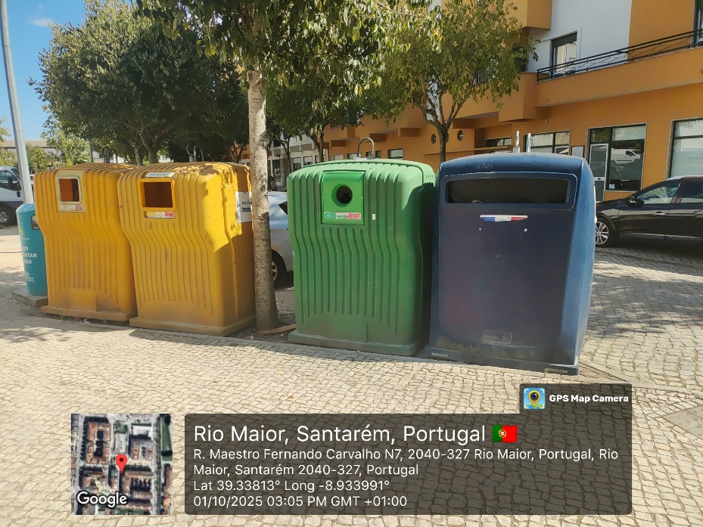
OVO container identification could not be confirmed using the available data, as the record refers to three waste types (paper, glass, and plastic), while the containers shown in the photo are each designed to hold only one specific waste type.

On-site Observation (Photo) | Data Recorded in Excel | Avg. Fill Level (2023) | Max. Fill Level (2023) | coordinates of the photo
Blue container → Paper & Cardboard | no record for this location | – |  | Longitude: -8.933991°
Green container → Glass | no record for this location | – | – | Latitude: 39.33813°
Yellow container → Mixed Packaging (plastics & metals) | ID (idcontento): 6092  Type: OVO,Volume: 2500 L | paper, glass, plastic | – | –

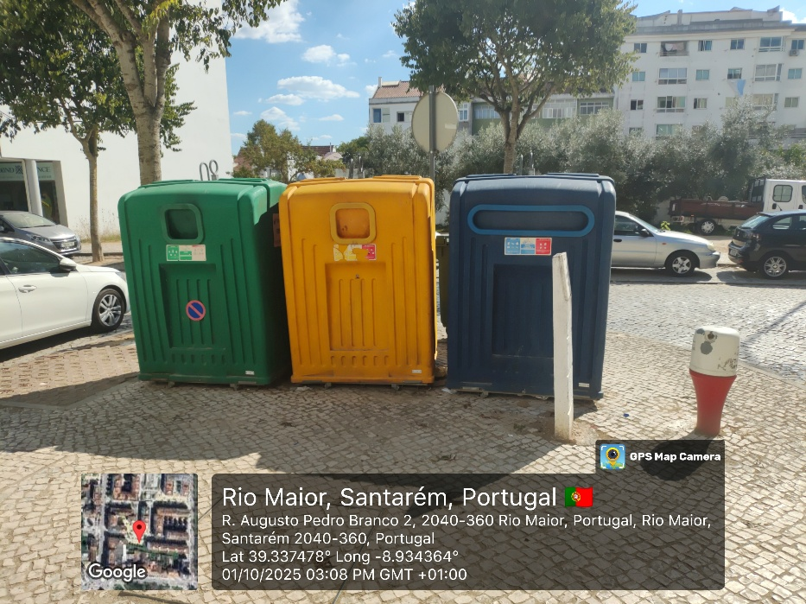
VRL container identification could not be confirmed using the available data, as the record refers to two waste types (paper, and plastic), while the containers shown in the photo are each designed to hold only one specific waste type.

On-site Observation (Photo) | Data Recorded in Excel | Avg. Fill Level (2023) | Max. Fill Level (2023) | coordinates of the photo
Blue container → Paper & Cardboard | ID (idcontento): 11983  Type: VRL, Volume: 2500 L | paper , plastic |  | Longitude: -8.934364°
Green container → Glass | no record for this location | – | – | Latitude: 39.337478°
Yellow container → Mixed Packaging (plastics & metals) | no record for this location | – | – | –
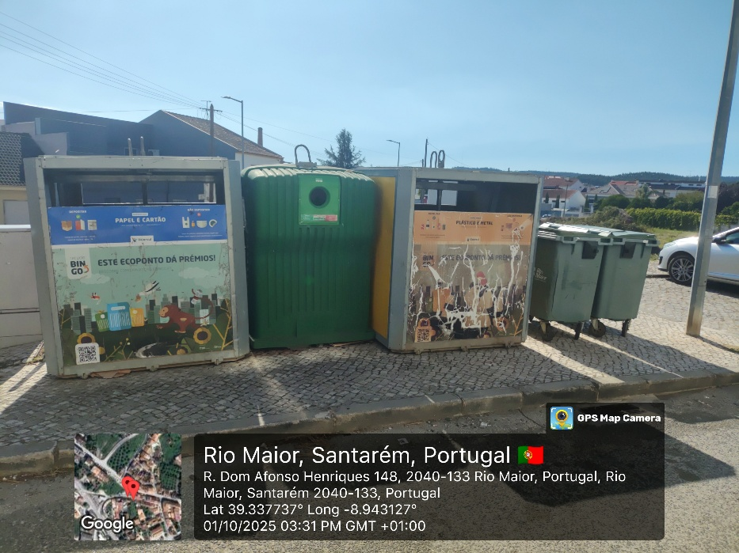
OVO container identification could not be confirmed using the available data, as the record refers to three waste types (paper, glass, and plastic), while the containers shown in the photo are each designed to hold only one specific waste type.

On-site Observation (Photo) | Data Recorded in Excel | Avg. Fill Level (2023) | Max. Fill Level (2023) | coordinates of the photo
Blue container → Paper & Cardboard | no record for this location | – |  | Longitude: -8.943127°
Green container → Glass | no record for this location | – | – | Latitude: 39.337737°
Yellow container → Mixed Packaging (plastics & metals) | ID (idcontento): 18704  Type: OVO,Volume: 2500 L | paper, glass, plastic | – | –

